https://smr.nucnet.org/news/doe-releases-positive-eia-for-critical-terrapower-natrium-reactor-experiment-8-4-2023
DOE Releases Positive EIA For ‘Critical’ TerraPower Natrium Reactor Experiment
By David Dalton
3 August 2023
Results will provide crucial data for company founded by Bill Gates
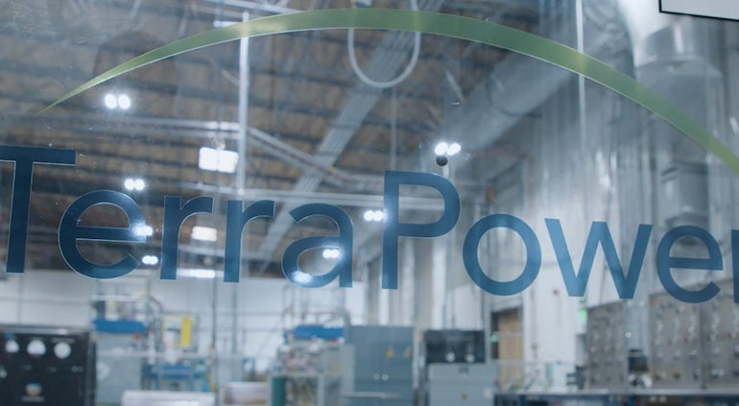
The US Department of Energy has released its final environmental impact assessment for an experiment that will be critical to the advancement of a Generation IV nuclear reactor being developed by Bill Gates’s company TerraPower.
The DOE said it had proposed a finding no significant impact for the design, construction, and operation of the molten chloride reactor experiment (MCRE) at Idaho National Laboratory (INL).
Analysis in the final environmental assessment determined the construction and operation of MCRE will have “no significant environmental or human health impact”, the DOE said.
The public can review the final environmental impact assessment and comment on the proposed finding.
The MCRE is scheduled to run for approximately six months at INL, after which it will be decommissioned.
The results will provide data crucial to the development of US-based TerraPower’s molten chloride fast reactor design, known as Natrium.
Test Will Be ‘First In World’
“MCRE will be the world’s first test of a fast-spectrum, salt-fueled reactor design,” said assistant secretary for nuclear energy Kathryn Huff. “This experiment will help advance an unexplored class of reactors and the environmental assessment is an important step toward demonstrating the technology.”
The MCFR would use liquid salts as both a coolant and fuel, allowing it to operate at high temperatures to produce heat or electricity more efficiently than today’s reactors.
In December 2020, the DOE selected a team led by Southern Company for a grant to design, build and test MCRE at INL.
Southern Company has already worked with TerraPower on installation of a test for reactor chloride salt systems. That test is expected to help validate thermal hydraulic and safety analyses needed for the MCFR.
As part of the project, the team will build the experimental system offsite and ship it to INL, where it will be fueled using materials currently in storage at the laboratory.
The 345-MW Natrium sodium-cooled fast reactor is being jointly developed by TerraPower and GE Hitachi.
In 2021, TerraPower announced its intention to build the first Natrium demonstration unit at a retiring coal facility in Kemmerer, Wyoming.
TerraPower this week announced the selection of four suppliers to support the Natrium project in Wyoming.
The company said Western Service Corporation of Maryland will provide the software platform and engineering services for the Natrium engineering simulator; Colorado-based James Fisher Technologies will design and build an injection casting furnace system that will demonstrate the basic functionality of the injection casting process; BWXT Canada will design the Natrium plant’s intermediate heat exchanger; and Curtiss-Wright Flow Control Service of North Carolina, will develop the reactor protection system.

